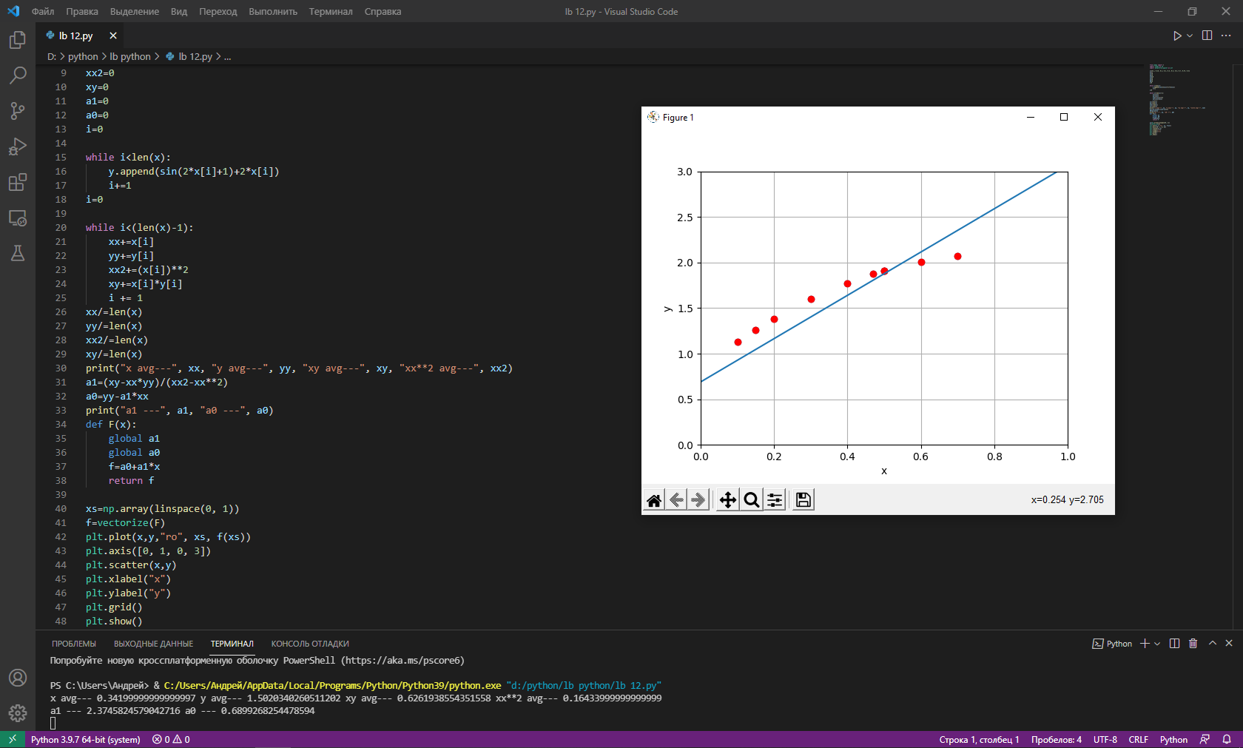

from numpy import \*

import numpy as np

import matplotlib.pyplot as plt

x=[0.1, 0.15, 0.2, 0.3, 0.4, 0.5, 0.6, 0.7, 0.47, 0.5]

y=[]

xx=0

yy=0

xx2=0

xy=0

a1=0

a0=0

i=0

while i<len(x):

    y.append(sin(2\*x[i]+1)+2\*x[i])

    i+=1

i=0

while i<(len(x)-1):

    xx+=x[i]

    yy+=y[i]

    xx2+=(x[i])\*\*2

    xy+=x[i]\*y[i]

    i += 1

xx/=len(x)

yy/=len(x)

xx2/=len(x)

xy/=len(x)

print("x avg---", xx, "y avg---", yy, "xy avg---", xy, "xx\*\*2 avg---", xx2)

a1=(xy-xx\*yy)/(xx2-xx\*\*2)

a0=yy-a1\*xx

print("a1 ---", a1, "a0 ---", a0)

def F(x):

    global a1

    global a0

    f=a0+a1\*x

    return f

xs=np.array(linspace(0, 1))

f=vectorize(F)

plt.plot(x,y,"ro", xs, f(xs))

plt.axis([0, 1, 0, 3])

plt.scatter(x,y)

plt.xlabel("x")

plt.ylabel("y")

plt.grid()

plt.show()